CSA1701-ARTIFICIAL INTELLIGENCE

NAME:A . Sri rama krishna
REG NO:192465011
DFS PROBLEM
Aim:
To write a Python program to implement Depth First Search (DFS) for traversing a graph.
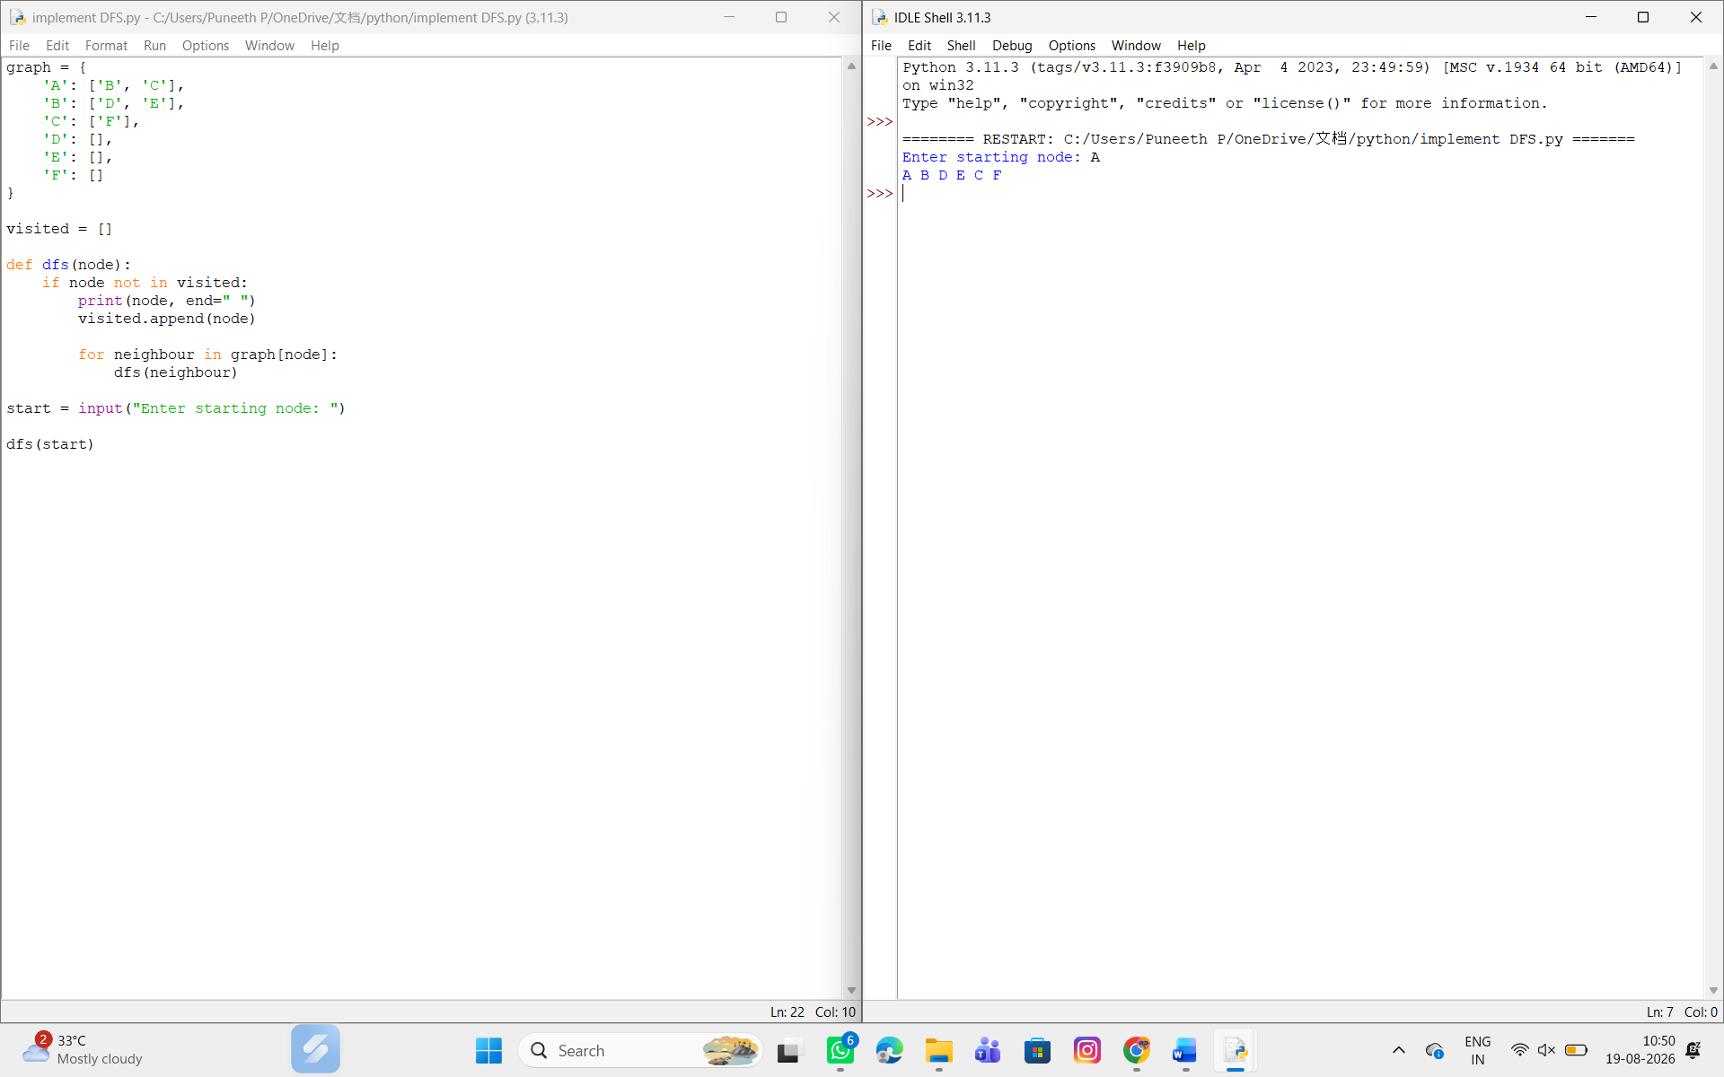

Result:
Thus, the Depth First Search (DFS) algorithm was successfully implemented using Python.

